1. Explore the personalitySubset dataset posted on blackboard datasets folder. Find and discuss the principal components that emerge.
   1. A factor analysis was conducted on the personality subset dataset as shown in the appendix under question 1. A total of 444 records were used in the analysis. When running the factor analysis with no specification on the number of factors used, we can conclude the number of factors necessary to run the analysis is 4 based on the eigenvalue. The eigenvalue for the first 4 rows is greater than 1, resulting in 4 factors needed for factor analysis according to the kaiser criterion. The remaining 6 rows have eigenvalues which are less than 1 which is why these are not considered to be added to the number of factors. After running the factor analysis with 4 factors, we can analyze the variables. When looking at the rotated factor pattern table, we can make many conclusions as well as generate questions on the analysis. The following variables load to following factors based on the absolute values:
      * Talkative – Factor 2
      * Finds Fault – Factor 4
      * Does a Through Job – Factor 1
      * Depressed – Factor 3
      * Reserved – Factor 2
      * Careless – Factor 1
      * Relaxed – Factor 3
      * Curious – Factor 4

It is difficult to place original and helpful variables into factors since both of these variables load onto multiple factors. The rotated factor pattern does a good job visualizing each variable and their corresponding factor. However, this is not the easiest to read. The path diagram displays visually which variable loads onto which factor. We can visually see that helpful and original load onto multiple variables. We should remove helpful and original and rerun the factor analysis.

1. The owner of Al Bawadi restaurant has collected survey feedback from his customers on various aspects : Taste, Seating Comfort, Service, Presentation of food, Freshness and Décor. He now wants you to analyze the data. The data is available in the file called Al Bawadi. What factor pattern do you detect from this data? Name and interpret the factors.
   1. As shown in the appendix, we have 426 records for factor analysis. According to the kaiser criterion and looking at the eigenvalue we can conclude 2 factors should be used. The rotated factor pattern tables show which variables load onto which factors. Below is the grouping of the variables into factors and names created for each factor group:

|  |  |
| --- | --- |
| **Food (Factor1)** | **Comfort/Service (Factor 2)** |
| Freshness | Décor |
| Taste | Seating Comfort |
| Presentation | Service |

As we can see in the rotated factor pattern and path diagram, freshness, taste and presentation without a doubt load onto factor 1 (food). Likewise, it is clear that décor, seating comfort, and service load onto factor 2 (comfort/service). Since each variable clearly loads onto one or the other factors, any removal of variables is unnecessary.

Appendix:

Question 1:

|  |  |
| --- | --- |
| **Input Data Type** | Raw Data |
| **Number of Records Read** | 459 |
| **Number of Records Used** | 444 |
| **N for Significance Tests** | 444 |

**Initial Factor Method: Principal Components**

**Prior Communality Estimates: ONE**

| **Eigenvalues of the Correlation Matrix: Total = 10 Average = 1** | | | | |
| --- | --- | --- | --- | --- |
|  | **Eigenvalue** | **Difference** | **Proportion** | **Cumulative** |
| **1** | 2.53009580 | 1.17545527 | 0.2530 | 0.2530 |
| **2** | 1.35464053 | 0.03521235 | 0.1355 | 0.3885 |
| **3** | 1.31942818 | 0.26808932 | 0.1319 | 0.5204 |
| **4** | 1.05133885 | 0.13550348 | 0.1051 | 0.6256 |
| **5** | 0.91583537 | 0.21613416 | 0.0916 | 0.7171 |
| **6** | 0.69970121 | 0.05431140 | 0.0700 | 0.7871 |
| **7** | 0.64538981 | 0.09747609 | 0.0645 | 0.8516 |
| **8** | 0.54791372 | 0.04003939 | 0.0548 | 0.9064 |
| **9** | 0.50787433 | 0.08009214 | 0.0508 | 0.9572 |
| **10** | 0.42778220 |  | 0.0428 | 1.0000 |

**10 factors will be retained by the NFACTOR criterion.**

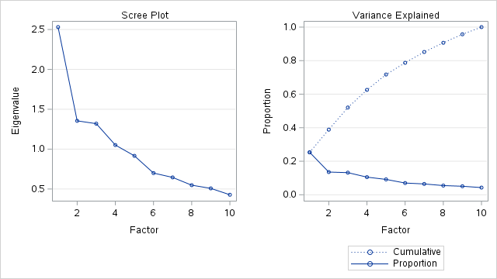

| **Factor Pattern** | | | | | |
| --- | --- | --- | --- | --- | --- |
|  | | **Factor1** | **Factor2** | **Factor3** | **Factor4** |
| **talkative** | talkative | 0.61552 | -0.24022 | 0.50411 | -0.22140 |
| **finds fault** | finds fault | -0.22614 | 0.13399 | 0.65873 | 0.37857 |
| **does a thorough job** | does a thorough job | 0.53094 | 0.61070 | 0.04706 | -0.01975 |
| **depressed** | depressed | -0.57455 | 0.36567 | 0.18138 | -0.42269 |
| **original** | original | 0.62772 | 0.04672 | 0.08514 | 0.03075 |
| **reserved** | reserved | -0.43987 | 0.62543 | -0.25675 | 0.27890 |
| **helpful** | helpful | 0.59549 | 0.20656 | -0.18915 | -0.47898 |
| **careless** | careless | -0.49632 | -0.44914 | 0.23531 | -0.10168 |
| **relaxed** | relaxed | 0.45215 | -0.25793 | -0.39868 | 0.52621 |
| **curious** | curious | 0.30855 | 0.26086 | 0.52249 | 0.29080 |

| **Variance Explained by Each Factor** | | | |
| --- | --- | --- | --- |
| **Factor1** | **Factor2** | **Factor3** | **Factor4** |
| 2.5300958 | 1.3546405 | 1.3194282 | 1.0513389 |

| **Final Communality Estimates: Total = 6.255503** | | | | | | | | | |
| --- | --- | --- | --- | --- | --- | --- | --- | --- | --- |
| **talkative** | **finds fault** | **does a thorough job** | **depressed** | **original** | **reserved** | **helpful** | **careless** | **relaxed** | **curious** |
| 0.73970998 | 0.64633582 | 0.65745676 | 0.67539108 | 0.40440515 | 0.72834588 | 0.66247460 | 0.51376620 | 0.70681158 | 0.52080631 |

**Rotation Method: Oblique Varimax**

| **Oblique Transformation Matrix** | | | | |
| --- | --- | --- | --- | --- |
|  | **1** | **2** | **3** | **4** |
| **1** | 0.55609 | 0.50022 | 0.42287 | -0.01512 |
| **2** | 0.83379 | -0.53538 | -0.38270 | 0.22673 |
| **3** | -0.14037 | 0.51647 | -0.39281 | 0.77857 |
| **4** | -0.18328 | -0.50480 | 0.76574 | 0.58808 |

| **Inter-Factor Correlations** | | | | |
| --- | --- | --- | --- | --- |
|  | **Factor1** | **Factor2** | **Factor3** | **Factor4** |
| **Factor1** | 1.00000 | 0.17095 | 0.18494 | 0.03087 |
| **Factor2** | 0.17095 | 1.00000 | 0.18846 | 0.02018 |
| **Factor3** | 0.18494 | 0.18846 | 1.00000 | -0.03998 |
| **Factor4** | 0.03087 | 0.02018 | -0.03998 | 1.00000 |

| **Rotated Factor Pattern (Standardized Regression Coefficients)** | | | | | |
| --- | --- | --- | --- | --- | --- |
|  | | **Factor1** | **Factor2** | **Factor3** | **Factor4** |
| **talkative** | talkative | 0.11181 | 0.80862 | -0.01534 | 0.19851 |
| **finds fault** | finds fault | -0.17588 | -0.03574 | -0.11578 | 0.76930 |
| **does a thorough job** | does a thorough job | 0.80146 | -0.02710 | -0.04281 | 0.15546 |
| **depressed** | depressed | 0.03741 | -0.17612 | -0.77782 | -0.01577 |
| **original** | original | 0.37044 | 0.31743 | 0.23767 | 0.08548 |
| **reserved** | reserved | 0.26179 | -0.82826 | -0.11094 | 0.11257 |
| **helpful** | helpful | 0.61771 | 0.33138 | -0.11971 | -0.39112 |
| **careless** | careless | -0.66488 | 0.16505 | -0.20829 | 0.02909 |
| **relaxed** | relaxed | -0.00411 | -0.10727 | 0.84946 | -0.06626 |
| **curious** | curious | 0.26245 | 0.13774 | 0.04808 | 0.63229 |

| **Reference Axis Correlations** | | | | |
| --- | --- | --- | --- | --- |
|  | **Factor1** | **Factor2** | **Factor3** | **Factor4** |
| **Factor1** | 1.00000 | -0.14007 | -0.15929 | -0.03536 |
| **Factor2** | -0.14007 | 1.00000 | -0.16288 | -0.02300 |
| **Factor3** | -0.15929 | -0.16288 | 1.00000 | 0.04962 |
| **Factor4** | -0.03536 | -0.02300 | 0.04962 | 1.00000 |

| **Reference Structure (Semipartial Correlations)** | | | | | |
| --- | --- | --- | --- | --- | --- |
|  | | **Factor1** | **Factor2** | **Factor3** | **Factor4** |
| **talkative** | talkative | 0.10871 | 0.78599 | -0.01486 | 0.19815 |
| **finds fault** | finds fault | -0.17102 | -0.03474 | -0.11214 | 0.76790 |
| **does a thorough job** | does a thorough job | 0.77928 | -0.02634 | -0.04146 | 0.15518 |
| **depressed** | depressed | 0.03637 | -0.17119 | -0.75338 | -0.01574 |
| **original** | original | 0.36018 | 0.30854 | 0.23020 | 0.08532 |
| **reserved** | reserved | 0.25455 | -0.80508 | -0.10745 | 0.11237 |
| **helpful** | helpful | 0.60062 | 0.32211 | -0.11595 | -0.39040 |
| **careless** | careless | -0.64648 | 0.16043 | -0.20174 | 0.02903 |
| **relaxed** | relaxed | -0.00399 | -0.10427 | 0.82276 | -0.06614 |
| **curious** | curious | 0.25518 | 0.13389 | 0.04657 | 0.63113 |

| **Variance Explained by Each Factor Eliminating Other Factors** | | | |
| --- | --- | --- | --- |
| **Factor1** | **Factor2** | **Factor3** | **Factor4** |
| 1.6880014 | 1.5506311 | 1.3798915 | 1.2291283 |

| **Factor Structure (Correlations)** | | | | | |
| --- | --- | --- | --- | --- | --- |
|  | | **Factor1** | **Factor2** | **Factor3** | **Factor4** |
| **talkative** | talkative | 0.25333 | 0.82885 | 0.14979 | 0.21890 |
| **finds fault** | finds fault | -0.17965 | -0.07210 | -0.18579 | 0.76778 |
| **does a thorough job** | does a thorough job | 0.79371 | 0.10498 | 0.09409 | 0.18137 |
| **depressed** | depressed | -0.13704 | -0.31663 | -0.80347 | 0.01293 |
| **original** | original | 0.47129 | 0.42727 | 0.36258 | 0.09382 |
| **reserved** | reserved | 0.10316 | -0.80215 | -0.22312 | 0.10837 |
| **helpful** | helpful | 0.64015 | 0.40652 | 0.07262 | -0.36057 |
| **careless** | careless | -0.67429 | 0.01273 | -0.30131 | 0.02022 |
| **relaxed** | relaxed | 0.13261 | 0.05078 | 0.83113 | -0.10252 |
| **curious** | curious | 0.31441 | 0.20443 | 0.09730 | 0.64125 |

| **Variance Explained by Each Factor Ignoring Other Factors** | | | |
| --- | --- | --- | --- |
| **Factor1** | **Factor2** | **Factor3** | **Factor4** |
| 1.9588652 | 1.8392621 | 1.6889200 | 1.2431348 |

| **Final Communality Estimates: Total = 6.255503** | | | | | | | | | |
| --- | --- | --- | --- | --- | --- | --- | --- | --- | --- |
| **talkative** | **finds fault** | **does a thorough job** | **depressed** | **original** | **reserved** | **helpful** | **careless** | **relaxed** | **curious** |
| 0.73970998 | 0.64633582 | 0.65745676 | 0.67539108 | 0.40440515 | 0.72834588 | 0.66247460 | 0.51376620 | 0.70681158 | 0.52080631 |

**Initial Factor Method: Principal Components**

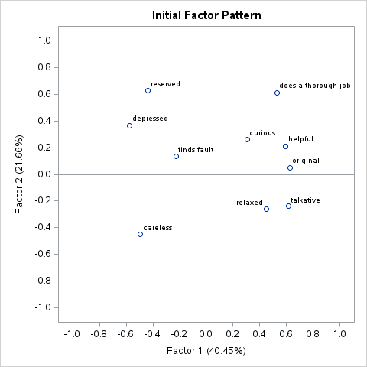

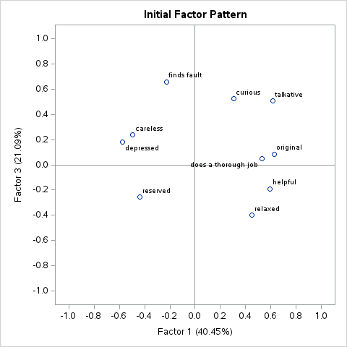

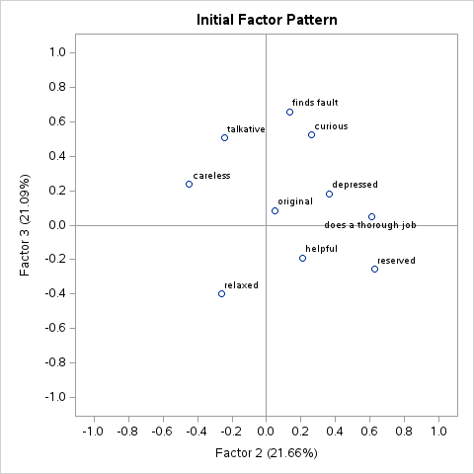

**Oblique Varimax-**

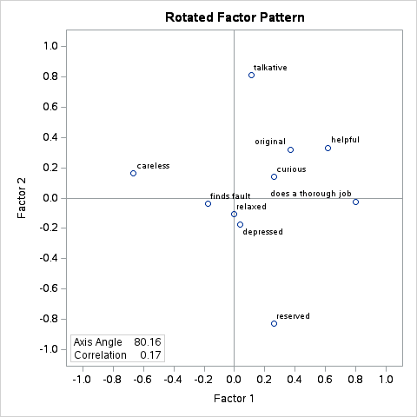

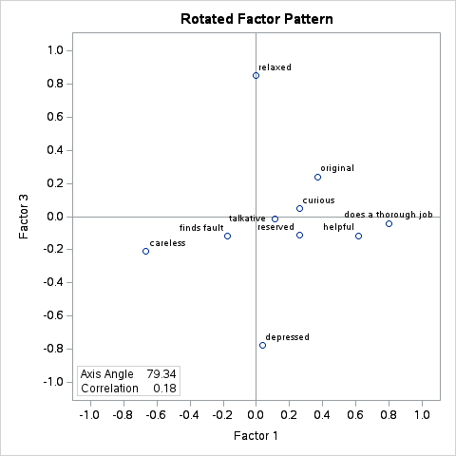

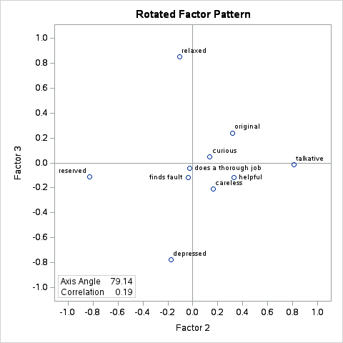

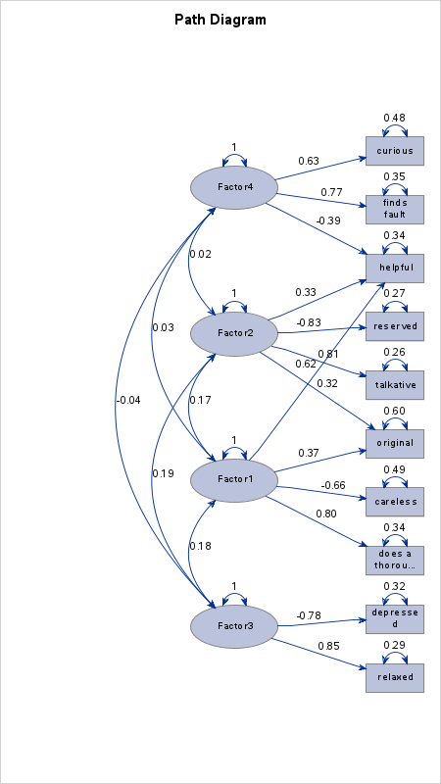

Question 2:

|  |  |
| --- | --- |
| **Input Data Type** | Raw Data |
| **Number of Records Read** | 426 |
| **Number of Records Used** | 426 |
| **N for Significance Tests** | 426 |

**Initial Factor Method: Principal Components**

**Prior Communality Estimates: ONE**

| **Eigenvalues of the Correlation Matrix: Total = 6 Average = 1** | | | | |
| --- | --- | --- | --- | --- |
|  | **Eigenvalue** | **Difference** | **Proportion** | **Cumulative** |
| **1** | 2.87916718 | 1.02360668 | 0.4799 | 0.4799 |
| **2** | 1.85556050 | 1.35181192 | 0.3093 | 0.7891 |
| **3** | 0.50374858 | 0.02787137 | 0.0840 | 0.8731 |
| **4** | 0.47587721 | 0.31394804 | 0.0793 | 0.9524 |
| **5** | 0.16192917 | 0.03821181 | 0.0270 | 0.9794 |
| **6** | 0.12371736 |  | 0.0206 | 1.0000 |

**2 factors will be retained by the NFACTOR criterion.**

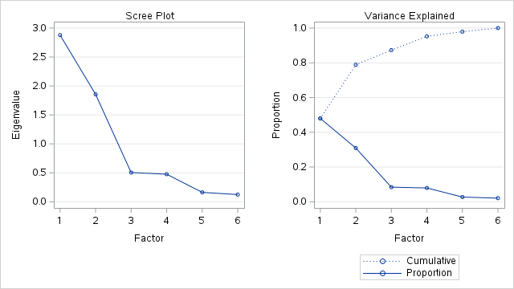

| **Factor Pattern** | | | |
| --- | --- | --- | --- |
|  | | **Factor1** | **Factor2** |
| **Taste** | Taste | 0.66006 | -0.52053 |
| **SeatingComfort** | SeatingComfort | 0.63263 | 0.56942 |
| **Service** | Service | 0.73351 | 0.55616 |
| **Presentation** | Presentation | 0.72036 | -0.57920 |
| **Freshness** | Freshness | 0.73879 | -0.52983 |
| **Décor** | Décor | 0.66370 | 0.57867 |

| **Variance Explained by Each Factor** | |
| --- | --- |
| **Factor1** | **Factor2** |
| 2.8791672 | 1.8555605 |

| **Final Communality Estimates: Total = 4.734728** | | | | | |
| --- | --- | --- | --- | --- | --- |
| **Taste** | **SeatingComfort** | **Service** | **Presentation** | **Freshness** | **Décor** |
| 0.70663218 | 0.72446107 | 0.84735255 | 0.85438807 | 0.82653619 | 0.77535762 |

**Initial Factor Method: Principal Components**

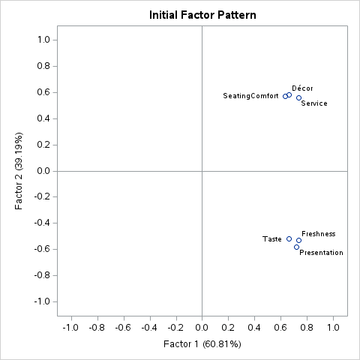

**Rotation Method: Oblique Varimax**

| **Oblique Transformation Matrix** | | |
| --- | --- | --- |
|  | **1** | **2** |
| **1** | 0.67527 | 0.64131 |
| **2** | -0.75369 | 0.78279 |

| **Inter-Factor Correlations** | | |
| --- | --- | --- |
|  | **Factor1** | **Factor2** |
| **Factor1** | 1.00000 | 0.15324 |
| **Factor2** | 0.15324 | 1.00000 |

| **Rotated Factor Pattern (Standardized Regression Coefficients)** | | | |
| --- | --- | --- | --- |
|  | | **Factor1** | **Factor2** |
| **Taste** | Taste | 0.83804 | 0.01585 |
| **SeatingComfort** | SeatingComfort | -0.00197 | 0.85145 |
| **Service** | Service | 0.07614 | 0.90577 |
| **Presentation** | Presentation | 0.92298 | 0.00858 |
| **Freshness** | Freshness | 0.89822 | 0.05905 |
| **Décor** | Décor | 0.01204 | 0.87862 |

| **Reference Axis Correlations** | | |
| --- | --- | --- |
|  | **Factor1** | **Factor2** |
| **Factor1** | 1.00000 | -0.15324 |
| **Factor2** | -0.15324 | 1.00000 |

| **Reference Structure (Semipartial Correlations)** | | | |
| --- | --- | --- | --- |
|  | | **Factor1** | **Factor2** |
| **Taste** | Taste | 0.82814 | 0.01566 |
| **SeatingComfort** | SeatingComfort | -0.00194 | 0.84140 |
| **Service** | Service | 0.07524 | 0.89507 |
| **Presentation** | Presentation | 0.91208 | 0.00848 |
| **Freshness** | Freshness | 0.88761 | 0.05835 |
| **Décor** | Décor | 0.01189 | 0.86824 |

| **Variance Explained by Each Factor Eliminating Other Factors** | |
| --- | --- |
| **Factor1** | **Factor2** |
| 2.3113581 | 2.2666678 |

| **Factor Structure (Correlations)** | | | |
| --- | --- | --- | --- |
|  | | **Factor1** | **Factor2** |
| **Taste** | Taste | 0.84047 | 0.14427 |
| **SeatingComfort** | SeatingComfort | 0.12851 | 0.85115 |
| **Service** | Service | 0.21494 | 0.91744 |
| **Presentation** | Presentation | 0.92429 | 0.15002 |
| **Freshness** | Freshness | 0.90727 | 0.19669 |
| **Décor** | Décor | 0.14667 | 0.88046 |

| **Variance Explained by Each Factor Ignoring Other Factors** | |
| --- | --- |
| **Factor1** | **Factor2** |
| 2.4680598 | 2.4233696 |

| **Final Communality Estimates: Total = 4.734728** | | | | | |
| --- | --- | --- | --- | --- | --- |
| **Taste** | **SeatingComfort** | **Service** | **Presentation** | **Freshness** | **Décor** |
| 0.70663218 | 0.72446107 | 0.84735255 | 0.85438807 | 0.82653619 | 0.77535762 |

**Rotation Method: Oblique Varimax**

